**PRACTICAL-6**

**AIM:**

**a.** Write a program to demonstrate the use of the following methods in a Tuple: i) count, ii) index

**Source Code:**

my_tuple = (1, 2, 3, 4, 2, 5, 2)

count_of_2 = my_tuple.count(2)

index_of_4 = my_tuple.index(4)

print("Count of 2 in the tuple:", count_of_2)

print("Index of 4 in the tuple:", index_of_4)

**Output:**

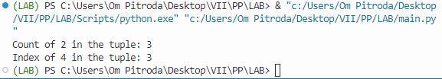

**b.** Create an empty dictionary and write a program to add single and multiple elements onto the dictionary.

**Source Code:**

my_dict = {}

my_dict['name'] = 'Om'

my_dict.update({'age': 20, 'city': 'Example City'})

print("Dictionary after adding elements:", my_dict)

**Output:**

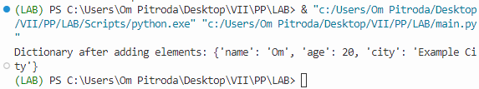

**c.** Write a program demonstrating the use of following functions of the Dictionary Data Structure:

i) Operations on Dictionary: copy(), fromkeys(), get(), items(), keys(), values()

ii) Manipulating Dictionary: update(), pop(), popitem(), clear()

**Source Code:**

e sample_dict = {'name': 'John', 'age': 25, 'city': 'Sample City'}

copy_dict = sample_dict.copy()

keys_list = ['name', 'age', 'city']

default_value = 'Not found'

new_dict = dict.fromkeys(keys_list, default_value)

age = sample_dict.get('age', 'N/A')

gender = sample_dict.get('gender', 'N/A')

dict_items = sample_dict.items()

dict_keys = sample_dict.keys()

dict_values = sample_dict.values()

print("Copy of Dictionary:", copy_dict)

print("New Dictionary with default values:", new_dict)

print("Age from Dictionary:", age)

print("Gender from Dictionary:", gender)

print("Items in Dictionary:", dict_items)

print("Keys in Dictionary:", dict_keys)

print("Values in Dictionary:", dict_values)

sample_dict.update({'city': 'New City', 'gender': 'Male'})

age = sample_dict.pop('age')

item = sample_dict.popitem()

sample_dict.clear()

print("Dictionary after updating:", sample_dict)

print("Popped Age from Dictionary:", age)

print("Popped Item from Dictionary:", item)

print("Dictionary after clearing:", sample_dict)

**Output:**

